Confidential Client Application
The Cambridge Center for Neuropsychology and Learning
2464 Massachusetts Avenue, Suite 129, Cambridge, MA 02140
617.354.5050 phone
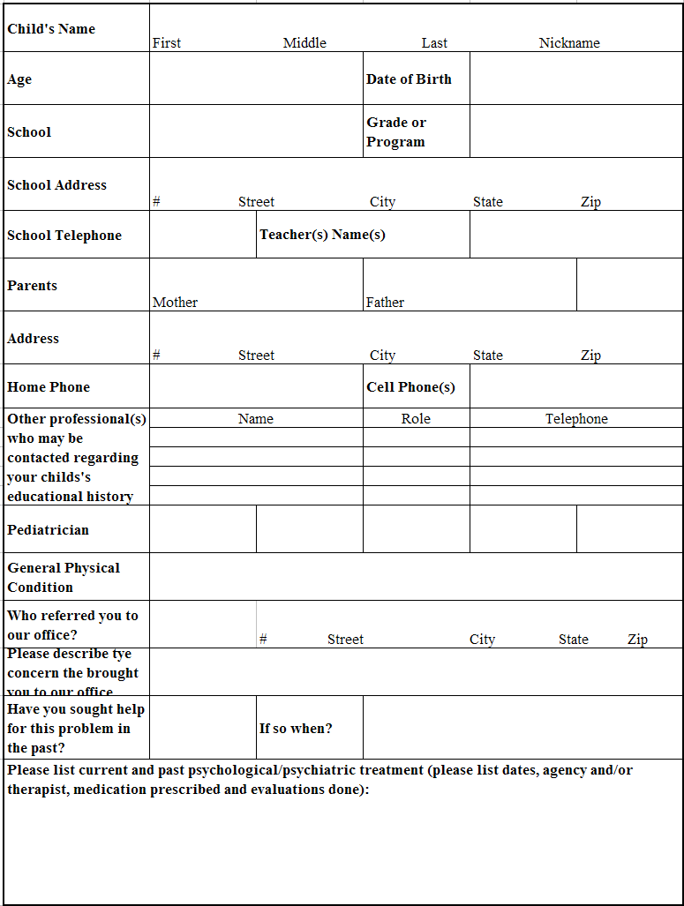
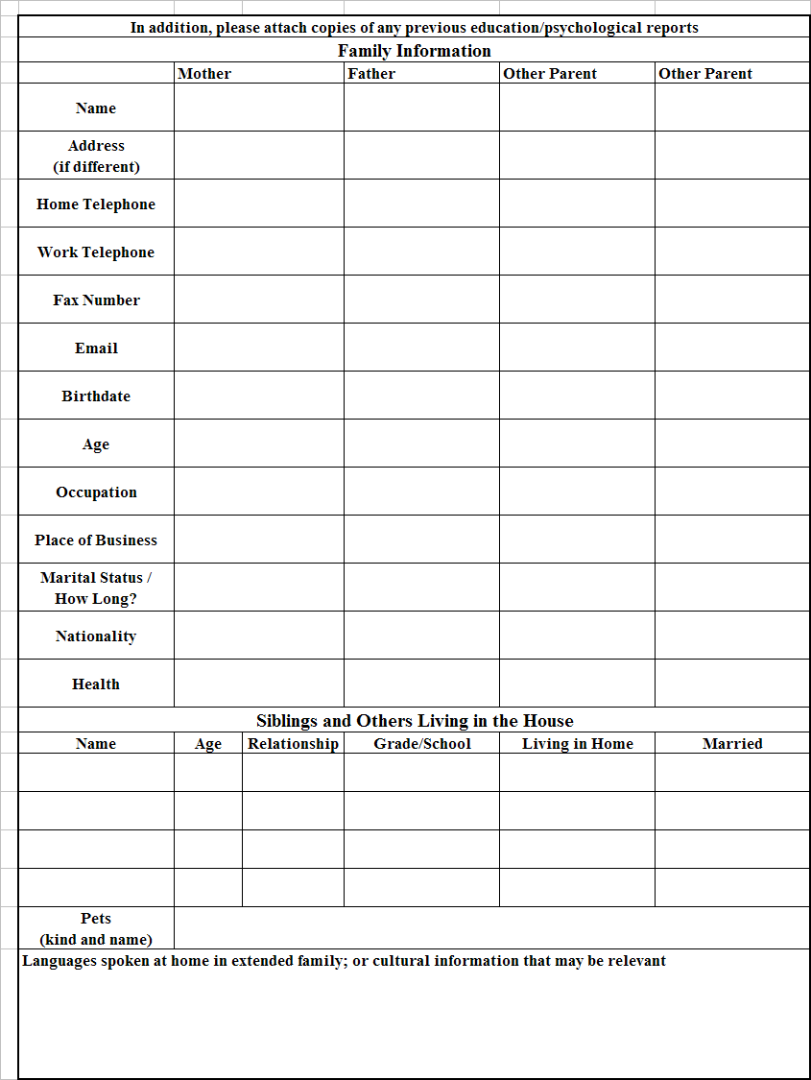

We encourage you to tell us your main goals for your child’s current evaluation. Describe any concerns or questions you may have about your child (i.e., at school, home, socially, medically). Please feel free to provide any additional information below.

